Scrub Jay Peripherals

Performing Calculations with Formulas and Functions

* PROJECT STEPS

1. Danilo Lewellen is an entrepreneur planning to manufacture and market an innovative handheld controller for virtual reality gaming. Danilo is building a business plan as he recruits investors and plans logistics for the launch of his new company, Scrub Jay Peripherals, and wants to use Excel to summarize data and create projections.  
     
   Switch to the *Sales Projections* worksheet. Use the values in the range B6:C6 to extend the incremented percentages to the range D6:H6.
2. Use the values in the range A7:A8 to extend the list of years to the range A9:A11.
3. Use **AutoFill** to fill the range A9:H11 with the formatting from the range A7:H8.
4. In cell B8, create a formula without using a function that multiplies the value in cell **B7** by the value in cell **B6** and then adds the value in **B7**. Update the cell reference to cell B6, from a relative reference to a mixed reference by making an absolute reference to row 6. Copy the formula from cell B8 to the range B9:B11 and then copy the formulas from the range B8:B11 to the range C8:H11.
5. Switch to the *Cost Estimates* worksheet. In cell A9, create a formula using the **AVERAGE** function that calculates the average of the values in the range **A5:A7**, then copy your formula to cell D9.
6. In cell A10, create a formula using the **MAX** function that identifies the maximum value in the range **A5:A7** and then copy your formula to cell D10.
7. In cell A11, create a formula using the **MIN** function that identifies the minimum value in the range **A5:A7** and then copy your formula to cell D11.
8. In cell B13, create a formula using the **VLOOKUP** function that looks up the value from cell **A11** in the range **A5:B7**, returns the value in column **2**, and specifies an exact match. Copy the formula to cell E13.
9. Switch to the *Profit Projections* worksheet. In cell H5, use the **TODAY** function to insert the current date.
10. In cell H7, create a formula that uses the **NETWORKDAYS** function to calculate the number of working days between the dates in cells **H5** and **H6**.
11. Use the values in the range B12:C12 to extend the incremented percentages to the range D12:H12.
12. Use the values in the range A13:A14 to extend the list of years to the range A15:A17.
13. In cell B13, create a formula without a function using absolute references that subtracts the values of cells **B5** and **B7** from cell **B6** and then multiplies the result by cell **B8**. Copy the formula from cell B13 to the range C13:H13.
14. In cell B14, create a formula without using a function that adds **1** to the value in cell **B12** and then multiplies the result by the value in cell **B13**. Update the reference to cell B12, from a relative reference to a mixed reference by making an absolute reference to row 12. Copy the formula from cell B14 to the range B15:B17 and then copy the formulas from the range B14:B17 to the range C14:H17.
15. Delete row 19.

Your workbook should look like the Final Figures on the following pages.

(Note: The value in cell H7 of the Profit Projections worksheet may differ from that shown below.)

* Final Figure 1: Sales Projections Worksheet

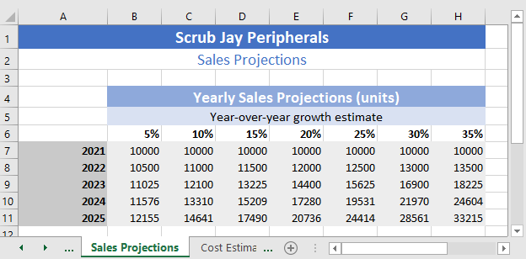

* Final Figure 2: Cost Estimates Worksheet

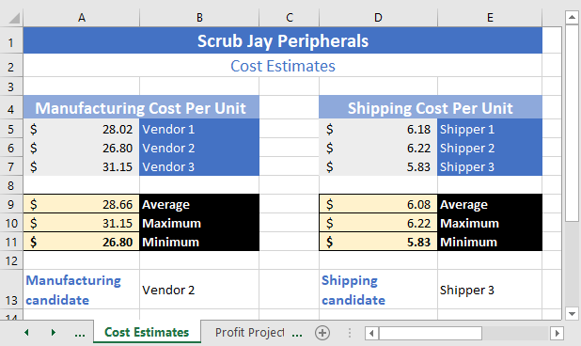

* Final Figure 3: Profit Projections Worksheet

